LIBRARY MANAGEMENT SYSTEM A MINI-PROJECT REPORT

Submitted by

Shabnam B | 240701485
Talapaneni sujitha 240701551
Sowmya A 240701523

In partial fulfillment of the award of the degree of

BACHELOR OF ENGINEERING IN

COMPUTER SCIENCE AND ENGINEERING
An Autonomous Institute CHENNAI
November 2025

BONAFIDE CERTIFICATE

Certified that this project “LIBRARY MANAGEMENT SYSTEM” is the bonafide work of “Shabnam B(240701485), Talapaneni sujitha(240701551),Sowmya A(240701523)” who carried out the project work under my supervision.

SIGNATURE
DEEPA
ASSISTANT PROFESSOR
Dept. of Computer Science and Engineering, Rajalakshmi Engineering College,
Chennai.

This mini project report is submitted for the viva voce examination to be held on

INTERNAL EXAMINER EXTERNAL EXAMINOR

ABSTRACT
The Library Management System is a Java-based desktop application developed using Java Swing and MySQL database. It provides an efficient and user- friendly interface for managing books, student registrations, and borrow records. The application includes modules for adding books, adding students with institutional email validation, displaying and searching books, and borrowing functionality with quantity and due-date tracking. It automates library operations and ensures data consistency while providing a smooth user experience through GUI integration.

ACKNOWLEDGEMENT
We express our sincere gratitude to our beloved and honorable Chairman MR. S. MEGANATHAN and Chairperson DR. M. THANGAM MEGANATHAN for their encouragement. We are thankful to our respected Principal DR. S. N. MURUGESAN for his guidance. We extend heartfelt thanks to our HOD DR. SRINIVASAN and Deputy HOD DR. J. MANORANJINI for their continuous support. We are deeply thankful to our guide DEEPA for his valuable assistance throughout the project. We also thank our family, friends, and the Department of Computer Science for their cooperation and motivation.

TABLE OF CONTENTS

ABSTRACT
- INTRODUCTION 1
- SYSTEM SPECIFICATIONS 3
- MODULE DESCRIPTION 4
- CODING 6
- SCREENSHOTS 9
- CONCLUSION AND FUTURE ENHANCEMENT 11
REFERENCES 12

LIST OF FIGURES

1.1 Main Interface | 9
1.2 Add Book Form | 9
1.3 Add Student Form | 10
1.4 Borrow Book Screen | 10
1.5 Database Schema | 11

CHAPTER 1 INTRODUCTION
The Library Management System is designed to automate and streamline library operations. It maintains records of books, students, and borrowing activities efficiently. This system replaces manual record-keeping with a digital interface built using Java Swing and MySQL.

CHAPTER 2

SYSTEM SPECIFICATIONS

Hardware Requirements: Processor: Intel i5 or above RAM: 4GB
Storage: 500MB

Software Requirements:
Operating System: Windows 10 or above Frontend: Java Swing
Backend: MySQL
IDE: Eclipse / IntelliJ IDEA

CHAPTER 3

MODULE DESCRIPTION

- Add Book Module – Allows librarians to add new books with details like title, author, and quantity.
- Add Student Module – Registers students with institutional email verification.
- Show All Books – Displays all book records from the database.
- Search Books – Enables keyword search by title or author.
- Borrow Book – Tracks issued books, validates student and stock availability, and updates quantity and due date automatically.

CHAPTER 4

CODING
import javax.swing.*; import java.awt.*; import java.awt.event.*; import java.sql.*;

public class Main extends JFrame { private Connection conn;
public Main() {
// Connect to database
conn = DBConnection.getConnection(); if (conn == null) {
JOptionPane.showMessageDialog(this, "Database Connection Failed!", "Error", JOptionPane.ERROR_MESSAGE);
System.exit(0);
}

setTitle("Library Management System"); setSize(500, 400); setDefaultCloseOperation(JFrame.EXIT_ON_CLOSE); setLocationRelativeTo(null);

// Buttons for operations
JButton addBookBtn = new JButton("Add Book"); JButton addStudentBtn = new JButton("Add Student");
JButton showBooksBtn = new JButton("Show All Books"); JButton searchBooksBtn = new JButton("Search Books"); JButton borrowBookBtn = new JButton("Borrow Book"); JButton exitBtn = new JButton("Exit");

addBookBtn.addActionListener(e -> addBook()); addStudentBtn.addActionListener(e -> addStudent()); showBooksBtn.addActionListener(e -> showAllBooks()); searchBooksBtn.addActionListener(e -> searchBooks());

borrowBookBtn.addActionListener(e -> borrowBook()); exitBtn.addActionListener(e -> System.exit(0));

JPanel panel = new JPanel(); panel.setLayout(new GridLayout(5, 1, 10, 10)); panel.add(addBookBtn); panel.add(addStudentBtn); panel.add(showBooksBtn); panel.add(searchBooksBtn); panel.add(borrowBookBtn); panel.add(exitBtn);

add(panel);
}

private void addBook() {
JTextField titleField = new JTextField(); JTextField authorField = new JTextField(); JTextField quantityField = new JTextField();

Object[] message = { "Title:", titleField, "Author:", authorField,
"Quantity:", quantityField
};

int option = JOptionPane.showConfirmDialog(this, message, "Add Book", JOptionPane.OK_CANCEL_OPTION);
if (option == JOptionPane.OK_OPTION) { try {
String sql = "INSERT INTO books(title, author, quantity) VALUES (?, ?, ?)"; PreparedStatement stmt = conn.prepareStatement(sql);
stmt.setString(1, titleField.getText()); stmt.setString(2, authorField.getText());
stmt.setInt(3, Integer.parseInt(quantityField.getText())); stmt.executeUpdate();
JOptionPane.showMessageDialog(this, "Book added successfully!");
} catch (SQLException ex) {
JOptionPane.showMessageDialog(this, "Error adding book: " + ex.getMessage());
}
}
}
private void addStudent() {

JTextField regField = new JTextField(); JTextField nameField = new JTextField(); JTextField deptField = new JTextField(); JTextField emailField = new JTextField();

Object[] message = {
"Register Number:", regField, "Name:", nameField, "Department:", deptField,
"Email (@rajalakshmi.edu.in):", emailField
};

int option = JOptionPane.showConfirmDialog(this, message, "Add Student", JOptionPane.OK_CANCEL_OPTION);
if (option == JOptionPane.OK_OPTION) { try {
String email = emailField.getText().trim();
if (!email.endsWith("@rajalakshmi.edu.in")) {
JOptionPane.showMessageDialog(this, "Only @rajalakshmi.edu.in emails allowed.");
return;
}

String sql = "INSERT INTO students(register_no, name, department, email) VALUES (?, ?, ?, ?)";
PreparedStatement stmt = conn.prepareStatement(sql); stmt.setString(1, regField.getText().trim()); stmt.setString(2, nameField.getText().trim()); stmt.setString(3, deptField.getText().trim()); stmt.setString(4, email);
stmt.executeUpdate();

JOptionPane.showMessageDialog(this, "Student added successfully!");
} catch (SQLException ex) {
JOptionPane.showMessageDialog(this, "Error adding student: " + ex.getMessage());
}
}
}

private void showAllBooks() { try {

String sql = "SELECT * FROM books"; Statement stmt = conn.createStatement(); ResultSet rs = stmt.executeQuery(sql);

StringBuilder sb = new StringBuilder(); while (rs.next()) {
sb.append("ID: ").append(rs.getInt("id"))
.append(", Title: ").append(rs.getString("title"))
.append(", Author: ").append(rs.getString("author"))
.append(", Quantity: ").append(rs.getInt("quantity"))
.append("\n");
}

JTextArea textArea = new JTextArea(sb.toString()); textArea.setEditable(false);
JScrollPane scrollPane = new JScrollPane(textArea); scrollPane.setPreferredSize(new Dimension(400, 300)); JOptionPane.showMessageDialog(this, scrollPane, "All Books",
JOptionPane.INFORMATION_MESSAGE);

} catch (SQLException ex) {
JOptionPane.showMessageDialog(this, "Error fetching books: " + ex.getMessage());
}
}
private void borrowBook() {
JTextField regNoField = new JTextField(); JTextField bookIdField = new JTextField();

Object[] message = {
"Student Register Number:", regNoField, "Book ID:", bookIdField
};

int option = JOptionPane.showConfirmDialog(this, message, "Borrow Book", JOptionPane.OK_CANCEL_OPTION);
if (option == JOptionPane.OK_OPTION) { try {
String regNo = regNoField.getText().trim();
int bookId = Integer.parseInt(bookIdField.getText());

// Fetch Student
PreparedStatement psStudent = conn.prepareStatement( "SELECT id, name FROM students WHERE register_no = ?"

);
psStudent.setString(1, regNo);
ResultSet rsStudent = psStudent.executeQuery();

if (!rsStudent.next()) {
JOptionPane.showMessageDialog(this, "Invalid Register Number"); return;
}

int studentId = rsStudent.getInt("id");
String studentName = rsStudent.getString("name");

// Fetch Book & Quantity
PreparedStatement psBook = conn.prepareStatement( "SELECT title, quantity FROM books WHERE id = ?"
);
psBook.setInt(1, bookId);
ResultSet rsBook = psBook.executeQuery();

if (!rsBook.next()) {
JOptionPane.showMessageDialog(this, " Invalid Book ID"); return;
}

String bookTitle = rsBook.getString("title"); int quantity = rsBook.getInt("quantity");

if (quantity <= 0) {
JOptionPane.showMessageDialog(this, "Book Out Of Stock"); return;
}

// Check if student already has this book borrowed & not returned PreparedStatement psCheck = conn.prepareStatement(
"SELECT id FROM borrow_recor WHERE student_id = ? AND book_id = ? AND status = 'BORROWED'"
);
psCheck.setInt(1, studentId); psCheck.setInt(2, bookId);
ResultSet rsCheck = psCheck.executeQuery();

if (rsCheck.next()) {
JOptionPane.showMessageDialog(this, " Student already borrowed this book and

has not returned it.");
return;
}

// Insert Borrow Record with due date = 7 days later PreparedStatement psBorrow = conn.prepareStatement(
"INSERT INTO borrow_recor (student_id, book_id, due_date) VALUES (?, ?, DATE_ADD(CURDATE(), INTERVAL 7 DAY))"
);
psBorrow.setInt(1, studentId); psBorrow.setInt(2, bookId); psBorrow.executeUpdate();

// Update Book Quantity
PreparedStatement psUpdate = conn.prepareStatement( "UPDATE books SET quantity = quantity - 1 WHERE id = ?"
);
psUpdate.setInt(1, bookId); psUpdate.executeUpdate();

JOptionPane.showMessageDialog(this, "✅ Borrow Successful\n\n" +
"Student: " + studentName + "\n" + "Reg No: " + regNo + "\n" +
"Book: " + bookTitle + "\n" +
"Due Date: 7 days from today\n" + "Status: BORROWED"
);

} catch (Exception ex) {
JOptionPane.showMessageDialog(this, "Error: " + ex.getMessage());
}
}
}

private void searchBooks() {
String query = JOptionPane.showInputDialog(this, "Enter book title or author to search:");
if (query == null || query.trim().isEmpty()) return; try {

String sql = "SELECT * FROM books WHERE title LIKE ? OR author LIKE ?"; PreparedStatement stmt = conn.prepareStatement(sql);
stmt.setString(1, "%" + query + "%"); stmt.setString(2, "%" + query + "%"); ResultSet rs = stmt.executeQuery();

StringBuilder sb = new StringBuilder(); while (rs.next()) {
sb.append("ID: ").append(rs.getInt("id"))
.append(", Title: ").append(rs.getString("title"))
.append(", Author: ").append(rs.getString("author"))
.append(", Quantity: ").append(rs.getInt("quantity"))
.append("\n");
}

if (sb.length() == 0) {
sb.append("No books found matching: ").append(query);
}

JTextArea textArea = new JTextArea(sb.toString()); textArea.setEditable(false);
JScrollPane scrollPane = new JScrollPane(textArea); scrollPane.setPreferredSize(new Dimension(400, 300)); JOptionPane.showMessageDialog(this, scrollPane, "Search Results",
JOptionPane.INFORMATION_MESSAGE);

} catch (SQLException ex) {
JOptionPane.showMessageDialog(this, "Error searching books: " + ex.getMessage());
}
}

public static void main(String[] args) { SwingUtilities.invokeLater(() -> new Main().setVisible(true));
}
}

CHAPTER 5

SCREENSHOTS

Main Interface:
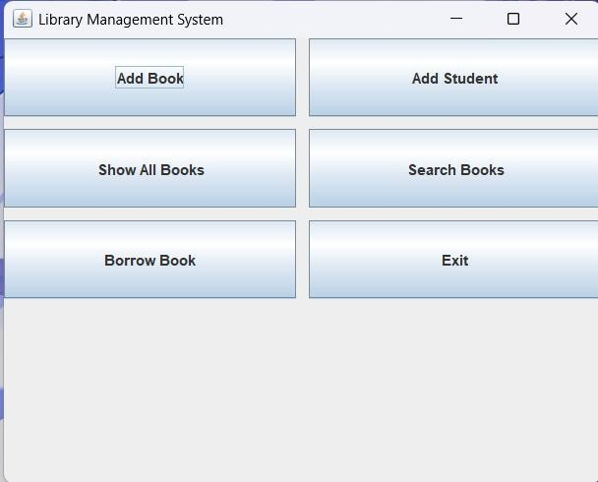

Add Book Form:
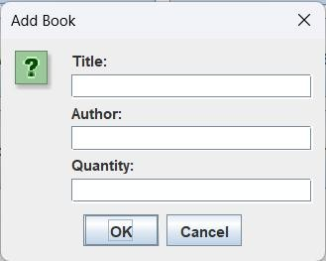

Add Student Form:
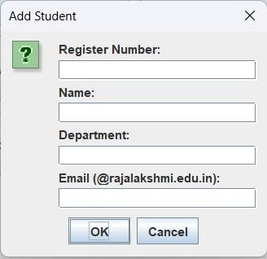

Borrow Book Screen :
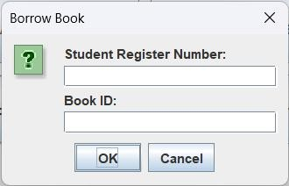

ER diagram:

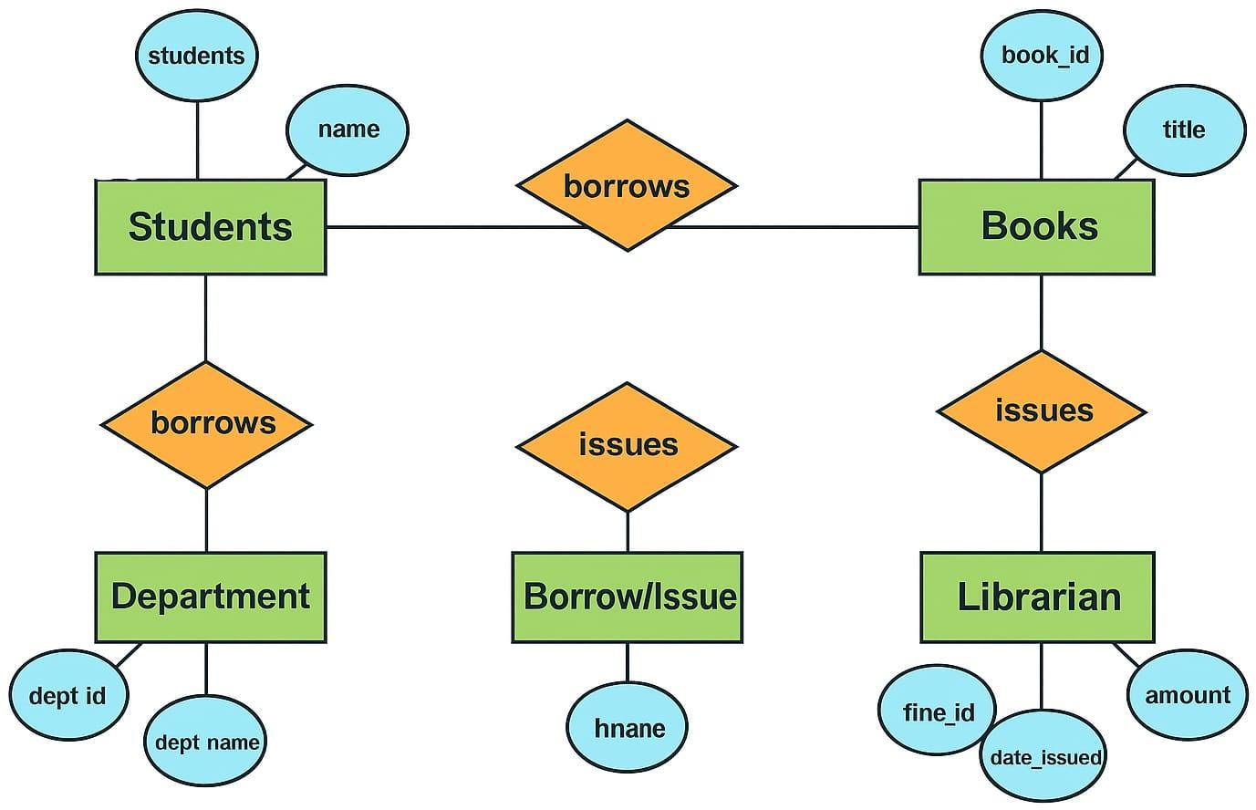

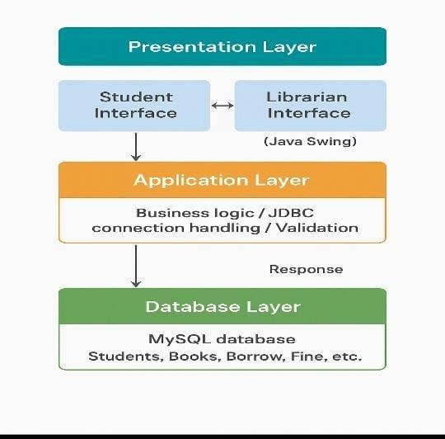
Architecture:

CHAPTER 6

CONCLUSION AND FUTURE ENHANCEMENT

The Library Management System successfully integrates Java Swing with MySQL to provide efficient library automation. It allows digital book management, borrowing tracking, and data consistency. Future upgrades may include online student login, fine calculation, overdue alerts, and cloud database integration.

REFERENCES

- https://docs.oracle.com/javase/
- https://dev.mysql.com/doc/
- https://www.javatpoint.com/java-swing
- https://www.geeksforgeeks.org/java-jdbc-tutorial/

